**דוח מעבדה 5**

**שמות מגישים:**

סער ויקטור – 312392822

אילון בן סימון – 312162951

**תרגיל 1**

קוד התכנית:

#include<stdio.h>

#include<stdlib.h>

#include<string.h>

#include<conio.h>

//struct define

typedef struct Student

{

char name[7], division[5];

char grade1[4], grade2[4];

}Student;

//function declerations

void Error_Msg(char* str);

void CopyData(FILE*in, FILE*out);

int main()

{

FILE *in, *out;

if (!(in = fopen("Students.txt", "r"))) //opens and checks the openning of Students.txt for read

Error_Msg("The input file is wrong");

if (!(out = fopen("StudentsNew.txt", "w"))) //opens and checks the openning of StudentsNew.txt for write

Error_Msg("The output file is wrong");

CopyData(in, out);

fclose(in);

fclose(out);

getch();

return 0;

}

void Error_Msg(char* str)

{

printf("\n%s", str);

exit(1);

}

//the function copy the relevant data to the the new file

void CopyData(FILE*in, FILE*out)

{

Student stud;

int grade1, grade2;

float avg;

while (fgets(stud.name, 7, in) != NULL)

{

fgets(stud.division, 5, in);

fgets(stud.grade1, 4, in);

fgets(stud.grade2, 4, in);

if (!strcmp("Comp", stud.division)) //comparing "Comp" to the division

{

grade1 = atoi(stud.grade1);

grade2 = atoi(stud.grade2);

avg = (grade1 + grade2) / 2.0;

fprintf(out, "%-7s %.2f\n", stud.name, avg);

}

}

}

פלט (לפני שינוי):

פלט (לאחר שינוי):

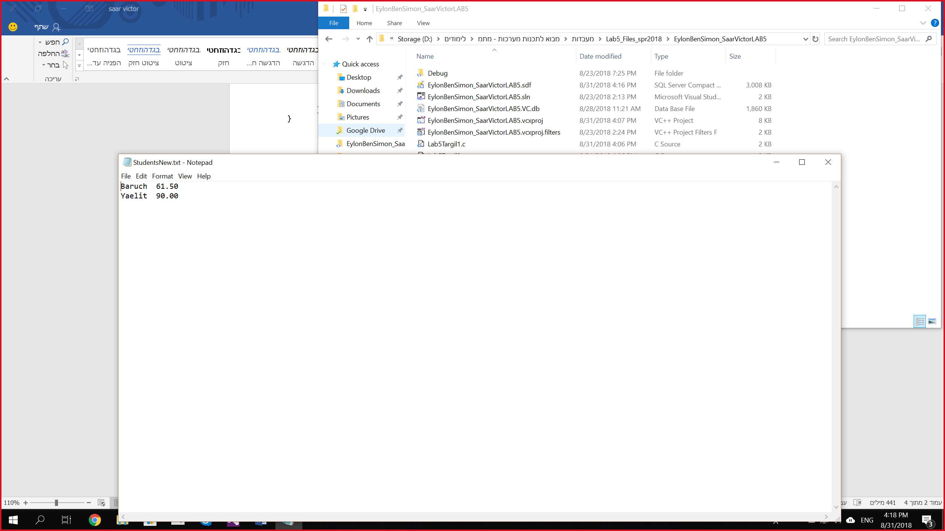

**תרגיל 2**

קוד התכנית:

#include <stdio.h>

#include <stdlib.h>

#include <string.h>

#include <conio.h>

#define DATA_LEN 23

//structure definition

typedef struct Student

{

char CourseName[4];

char ID[5];

char FullName[17];

}Student;

//function decleration

void Get_Lost(char *);

void Sort(FILE *);

void ScanTwoStudents(Student*stud1, Student*stud2, FILE* file);

void PrintToFile(Student*stud1, Student*stud2, FILE* file);

int main()

{

FILE *file;

file = fopen("Stud.txt", "r+");

if (file == NULL) //check if the open was successful

Get_Lost("The input file is wrong"); //Handle case where couldn't open file.

Sort(file);

fclose(file);

getch();

return 0;

}

void Get_Lost(char *s)

{

puts(s);

exit(1);

}

void Sort(FILE *file)

{

int i, j;

Student stud1, stud2;

int numOfStudents;

char *tempID;

fseek(file, 0, SEEK_END);

numOfStudents = (ftell(file)) / DATA_LEN; //checking how many students are in the file

fseek(file, 0, SEEK_SET);

for (j = 0; j < numOfStudents; j++) //loop that runs numOfStudents times

{

for (i = 0; i < numOfStudents - j - 1; i++) //loop to print to the file the maximum Student ID on the right

{

ScanTwoStudents(&stud1, &stud2, file);

if (strcmp(stud1.ID, stud2.ID) > 0) //checking which ID is greater

{

fseek(file, (-2)*DATA_LEN, SEEK_CUR);

PrintToFile(&stud2, &stud1, file);

}

fseek(file, (-1)*DATA_LEN, SEEK_CUR);

} //end loop

fseek(file, 0, SEEK_SET);

} //end loop

}

//the function scanning from the file the data of 2 students

void ScanTwoStudents(Student*stud1, Student*stud2, FILE* file)

{

fgets(stud1->CourseName, 4, file);

fgets(stud1->ID, 5, file);

fgets(stud1->FullName, 17, file);

fgets(stud2->CourseName, 4, file);

fgets(stud2->ID, 5, file);

fgets(stud2->FullName, 17, file);

}

//the function prints the data of to students to the file

void PrintToFile(Student*stud1, Student*stud2, FILE* file)

{

fprintf(file, "%s%s%s", stud1->CourseName, stud1->ID, stud1->FullName);

fprintf(file, "%s%s%s", stud2->CourseName, stud2->ID, stud2->FullName);

}

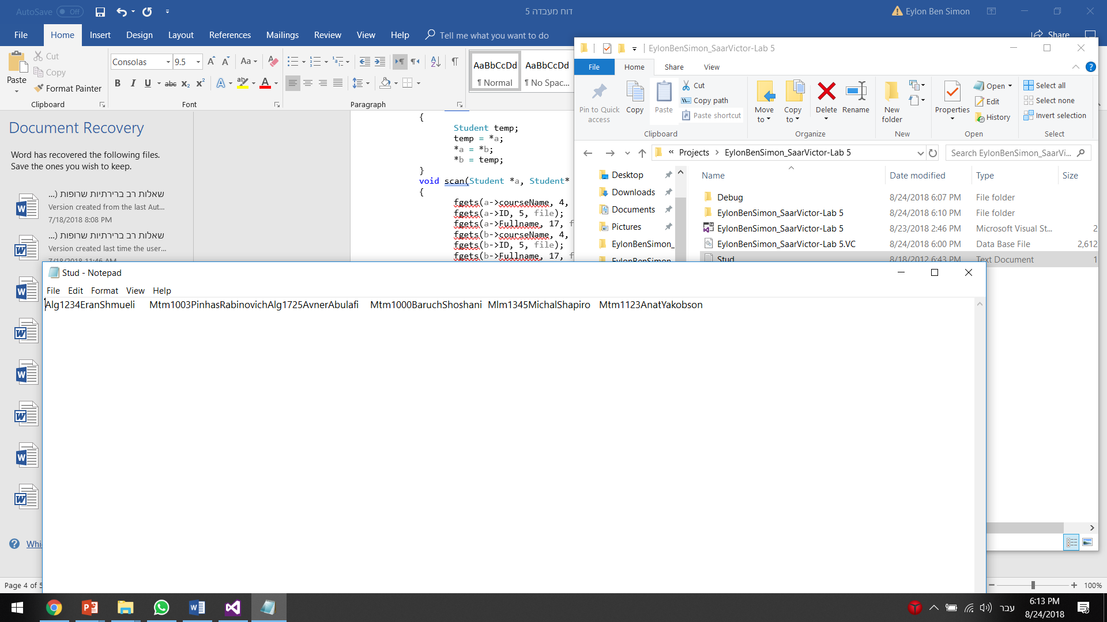פלט (לפני שינוי):

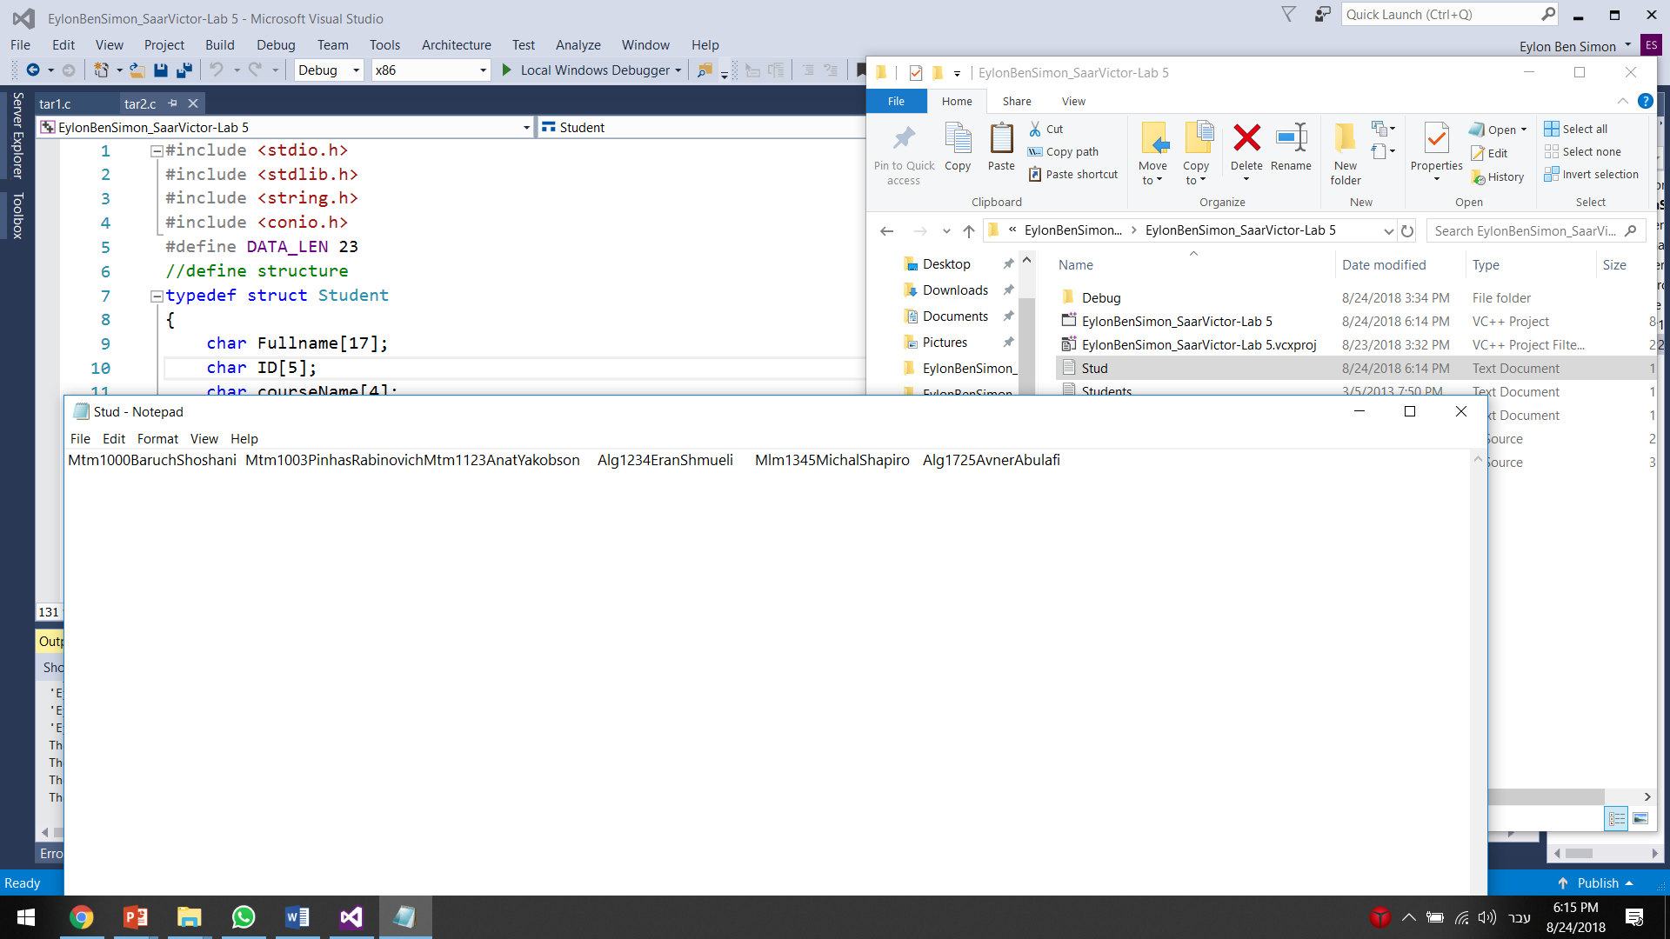פלט (אחרי שינוי):